Gnarly Landscape Utilities:
Resistance and Habitat Calculator
User Guide
Version 1.0—Updated October 2013

Brad H. McRae¹, Andrew J. Shirk², and Jim T. Platt¹
¹The Nature Conservancy
²The University of Washington Climate Impacts Group

Preferred Citation
McRae, B.H., A.J. Shirk, and J.T. Platt. 2013. Gnarly Landscape Utilities: Resistance and Habitat Calculator User Guide. The Nature Conservancy, Seattle WA. Available at: http://www.circuitscape.org/linkagemapper.

Acknowledgements
We thank the Washington Habitat Connectivity Working Group for feedback on these tools as they were being developed.

Software Requirements and Licensing
The Gnarly Landscape Utilities require AcrGIS 10 with the Spatial Analyst extension. This software is provided free of charge under a GNU General Public License.

1. Introduction
These tools were developed to assist the Washington Wildlife Habitat Connectivity Working Group (WHCWG) in their habitat connectivity assessments (WHCWG 2010, 2012). They don’t do the hard work of modeling habitat or resistance per se. The user must come up with their own model of how different landscape features affect habitat quality or movement. Before diving in, we strongly recommend that users first acquaint themselves with the process and challenges of connectivity modeling by consulting published resources. Good places to start include overviews on the Corridor Design and Connecting Landscapes websites (and the Corridor Design website has similar tools). Beier et al. (2009), Spear et al. (2010), Beier et al. (2011) and Zeller et al. (2012) also offer helpful advice on resistance mapping and connectivity analysis in general.

Once these models have been developed, the tools described here can readily be used to create habitat and resistance surfaces scores stored in an Excel spreadsheet.

2. Installation
The Resistance and Habitat Calculator toolset is part of Gnarly Landscape Utilities, an ArcGIS toolbox that can be added to any ArcGIS map document from the toolbox window. In addition to the toolbox, we provide example data in the ‘ResistanceHabitatDemo’ folder, including example input layers and input parameter spreadsheet.

To install, unzip the toolbox package into a directory of your choosing (make sure you have read/write permission for the directory). Then add the Gnarly Landscape Utilities toolbox to your toolboxes following standard procedures found on the ArcGIS help pages.

This tool requires the Python package openpyxl . We have included a compatible version in the ‘toolbox\scripts’ subfolder of the Gnarly Landscape Utilities install directory. If you use the included version, make sure you keep it in the same directory as the Gnarly Landscape Utilities toolbox (that’s where the toolbox expects to find it if it isn’t in the site-packages folder). You can also install it (available here) in the site-packages folder of your ArcGIS Python directory.

3. Using the tools
Tool #1: Resistance and Habitat Calculator
To use this tool, resistance scores for each class in each layer should be first recorded in an Excel spreadsheet in the same format as shown in Fig. 1. You can find a geodatabase with example input data and a corresponding Excel spreadsheet in the ‘ResistanceHabitatDemo’ directory. There is also an ArcMap document (ResistanceHabitat_Demo.mxd) that has the Gnarly Landscape Utilities installed.

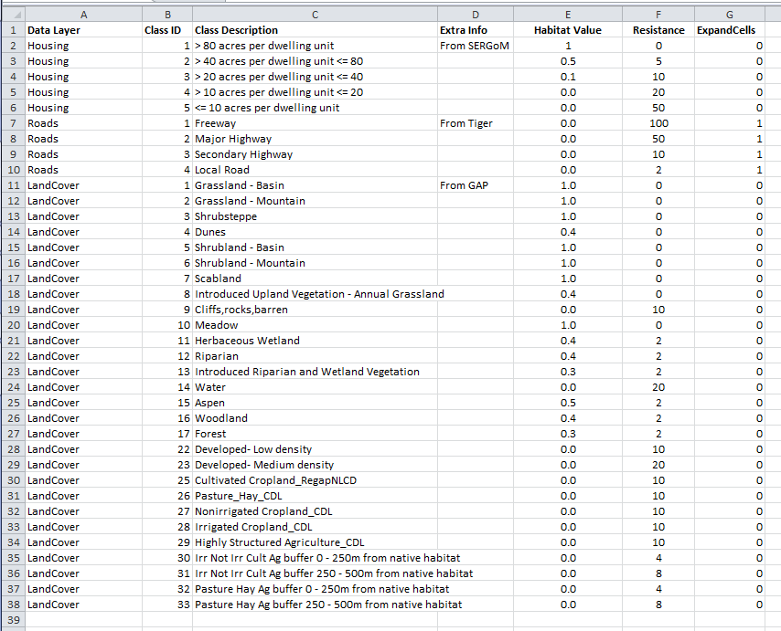
Fig. 1. Excel sheet from ‘ResistanceHabitatDemo’ directory. This is an example for a made-up species. Grasslands and shrublands without housing nearby constitute the best habitat (column E). Water, roads, developed areas, agriculture, and some vegetation types pose barriers of differing strengths (column F). In this case, road features would be expanded by 1 pixel (column G).

You’ll need the layer name and class ID in columns A and B, respectively. Column C is for your own reference and is ignored by the tool. Either habitat or resistance scores (or both) should be in columns E and F.

Creating Resistance Maps
The Resistance and Habitat Calculator tool will create a resistance map using the values in column F of the Excel spreadsheet. Resistance values can be calculated as the maximum or the sum across all input layers. The WHCWG summed resistance values across input layers for focal species but used maximum resistances across input layers for landscape integrity analyses (see WHCWG 2010 for details). Using the sum acknowledges that the effects of different barriers can be cumulative (e.g. a road with a powerline running alongside it may present greater resistance to movement than a road or powerline alone). On the other hand, taking the maximum is simpler and can avoid double-counting of features that show up in multiple layers. If the sum is used, then we recommend setting minimum resistances (resistance for ideal conditions for each layer) in the excel sheet to zero, and running the tool with the “Add one to resistance raster” box checked. In this way, ideal dispersal habitat will have a value of one, with resistances increasing for less ideal conditions (see the “lessons learned” section at the end of this document).

Column G denotes whether all features in a layer should be expanded by a given number of cells before combining with other layers (e.g. to make roads ‘fatter,’ ensuring that their barrier properties are preserved if output layers are to be coarsened down the road. All features will be expanded by the number of cells denoted in the row corresponding to the first class ID. When two features expand into one another, the feature with the greater resistance will be preserved. We included the ability to expand features because coarsening (e.g. from 30 to 90m) can produce low-resistance ‘holes’ in linear features. Because all features in a layer will be expanded, you will need to create separate rasters if you only want some features expanded (e.g., if you want to ‘fatten’ highways but not local roads).

All input rasters should be stored in a single file geodatabase. It’s good practice to have all rasters in the same projection with the same snap raster (i.e., with cells from different layers aligning perfectly with one another). The first raster encountered in the excel sheet will be used to set the spatial reference, extent, and cell size for all analyses.

Creating Habitat Maps
Habitat map calculations are very similar to resistance map calculations. Habitat values are specified in column E. Features are not expanded in habitat calculations (column G is ignored). The maximum, minimum, or product can be used in calculations.

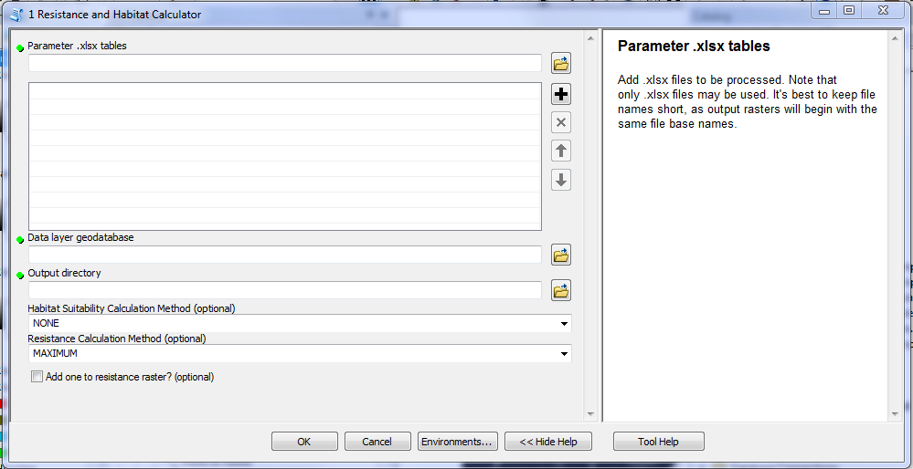
Fig. 2. Resistance and Habitat Calculator tool.

Tool #2: Raster cell size coarsener
As its name suggests, this tool generalizes habitat and resistance rasters to larger cell sizes. It will 1) optionally smooth pixel values by taking the average in a NxN window and then 2) coarsen the result to a larger cell size taking the minimum, maximum, or average value of smoothed values in the NxN window. You can process up to 5 rasters at a time.

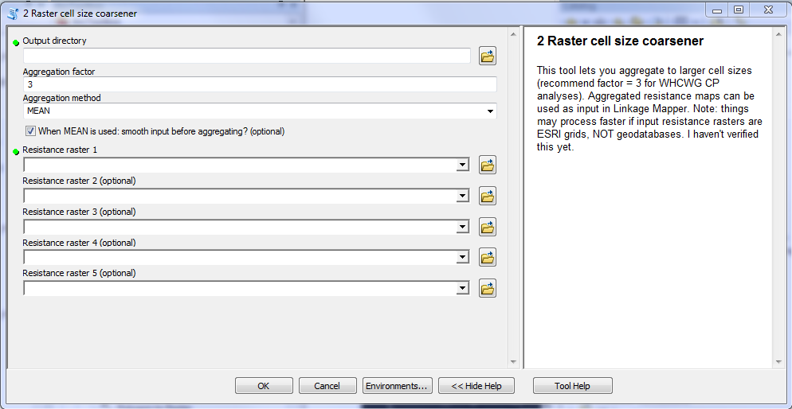
Fig 3. Raster cell size coarsener tool. Note: you will probably want to coarsen resistance or habitat rasters instead of base rasters. Because base rasters are categorical, it’s harder to control whether low or high quality features will predominate at coarser scales.

4. Some lessons learned from habitat connectivity analyses in Washington
In general, it is good practice for the final resistance layer to have resistances for ideal dispersal habitat of one, with resistance values increasing for less ideal conditions and barriers (e.g, having resistances range from 1-100, 1-1000, or 1-10000). This way, least-cost distances equal Euclidean distances under ideal conditions (which comes in very useful for interpretation down the road). Here’s how we described this for our analyses in Washington (from Chapter 2 WHCWG (2010):

“We assigned relative resistance values to different landscape features, such as different classes of roads or various land cover/land-use types. Conceptually, we defined the resistance contributed by each landscape feature as the number of additional grid cells of ideal habitat a given species would move through to avoid one grid cell of the feature being considered. For each landscape feature, we estimated the additional resistance to movement imposed by the feature relative to ideal habitat, ranging from zero for ideal habitat to infinity for complete barriers. The final resistance layer for each species was then derived by summing the resistances from each input layer and adding one (to account for Euclidean distance). Each cell in the resulting resistance layer for each species had a resistance value summing the individual resistances from up to six GIS base layers, including land cover/land-use, elevation, slope, housing density, roads, and forest structure.”

We also recommend consulting the subsequent Columbia Plateau connectivity analysis (WHCWG 2012), which refined the statewide methods.

In our Washington analyses, we found that NLCD-based data (including GAP land cover data) often erroneously classified roads (even dirt roads) as developed areas. We recommend pre-processing any data that are based on NLCD to shrink developed classes by one or two pixels, replacing them with surrounding land cover types. This is to avoid the creation of hard barriers out of misclassified features, particularly if these are captured in other input layers (such as TIGER roads data). For the Washington analyses, we used the 'shrink' function, which allowed us to control how many pixels got eaten away from the edge of any developed region. These pixels were replaced by their nearest non-developed neighbor values. Using the process with a setting of 2 pixels removed linear and small features classified as developed. The remaining developed pixels tend to be in truly developed areas (e.g. urban or industrial areas). We then used the CON statement in raster calculator to set anything that was NoData in the shrunken raster to the original LULC value (this step taken because some nodata pixels "nibbled in" from the edges of the study area).

Take your time to carefully look at the results of any resistance or habitat model. Make sure that linear features that should act as barriers really do. You may need to expand these features (or rasterize them at a coarser cell size from the beginning) to preserve their barrier qualities.

5. Support
Please email Brad McRae (mcrae@circuitscape.org) if you have trouble. Bug reports and suggestions for improvement are especially welcome.

6. Further reading
Beier P, Majka DR, Newell SL. 2009. Uncertainty analysis of least-cost modeling for designing wildlife linkages. Ecological Applications 19: 2067–2077
Beier, P., W. Spencer, R. Baldwin, and B.H. McRae. 2011. Best science practices for developing regional connectivity maps. Conservation Biology 25(5): 879-892
Spear, S.F., N. Balkenhol, M.-J. Fortin, B.H. McRae and K. Scribner. 2010. Use of resistance surfaces for landscape genetic studies: Considerations of parameterization and analysis. Molecular Ecology 19(17): 3576-3591.
Washington Wildlife Habitat Connectivity Working Group (WHCWG). 2010. Washington Connected Landscapes Project: Statewide Analysis. Washington Departments of Fish and Wildlife, and Transportation, Olympia, WA. Available at: http://waconnected.org/statewide-analysis/.
Washington Wildlife Habitat Connectivity Working Group (WHCWG). 2012. Washington Connected Landscapes Project: Analysis of the Columbia Plateau Ecoregion. Washington Departments of Fish and Wildlife, and Transportation, Olympia, WA. Available at: http://waconnected.org/columbia-plateau-ecoregion/
Zeller K.A., McGarigal K., and Whiteley A.R. 2012. Estimating landscape resistance to movement: a review. Landscape Ecology 27: 777–797.

You can also find similar tools and modeling guidance on the Corridor Design website.

